**General Chemistry LabII-1112L**

# Lab Report#___8___

Andrew Kalathra, Department of Chemistry and Biochemistry, Lamar University, Beaumont TX 77710

**Title- Equilibrium of the Iron (III) Cation and the Thiocyanate Anion**

**Objective**- To test the extent of equilibrium reactions by changing the concentration and the amount of the reactants and products (because this is an equilibrium reaction). The reaction we used to observe this was Fe3+ + SCN- -->FeSCN2+.

**Procedure-** 1. First, we collected .2 M Fe(NO3)3 (in .1 M HNO3 solution), we collected .002 M NaSCN (in .1 M HNO3), and some .1 M HNO3 solution.

2. Next, we mixed 5 mL Fe(NO3)3 solution and 5 NaSCN mL solution, we kept the new solution aside.

3. Next, we obtained and labelled 5 test tubes (along with 5 stoppers), and filled each with the correct amounts labelled on table 1. In short, every tube had 5 mL of .2 M Fe(NO3)3 along with a mixture of NaSCN (slowly increasing in .5 mL increments, starting from 0 and ending at 2) & HNO3 (slowly decreasing in .5 mL increments, starting at 5 and ending at 3).

4. We shook the tubes, extracted some from each solution and kept them is separate cuvettes. We then measured their absorbance at 470nm using the colorimeter.

5. We then cleaned the 5 test tubes and reused them. We repeated our experiment, except that we replaced the .2 M Fe(NO3)3 with .002 M Fe(NO3)3.

6. All other charts and questions were answered in the process of writing this report, outside of the laboratory.

**Data and Results**

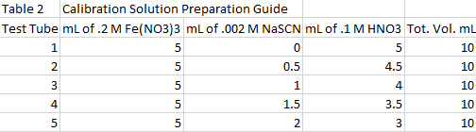

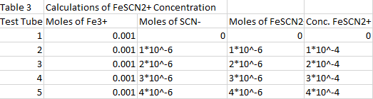

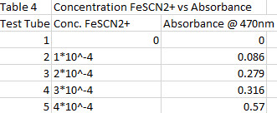

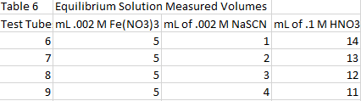

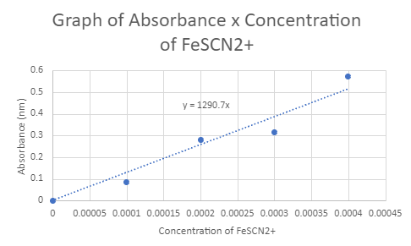

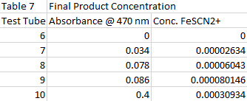

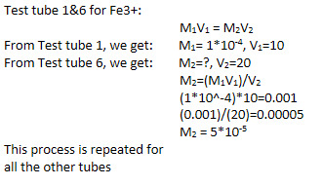

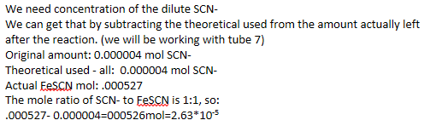

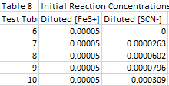

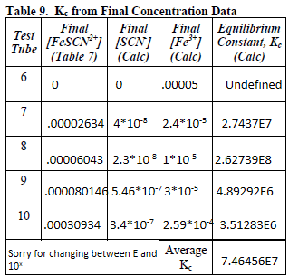

**Conclusions**

By the end of this lab (physically) me and my teammate knew that some of our results were not how they were meant to be, but we were content. While doing this lab report, I am concerned about my grade. I got the concept of how the absorbance of the concentration could be translated from different solutions to get the final equilibrium concentration of a reaction, but this lab was not our proudest. During the lab, there were some human errors that occurred. Some of the results that I got might be off because of the human errors that occurred. There was some inconstancy in our results and during our calculations.

**Key Questions-**

1. If a reaction is in equilibrium why would be incorrect to describe it as being stopped? -Though the concentration may not be changing, the reaction is not stopped because an constant amount of reactants and products are being produced at the same time.

2. In the general equilibrium expression above, which terms are in the denominator and which terms are in the numerator? - The products are in the numerator while the reactants are in the denominator.

3. In the general equilibrium expression above which terms represent the concentration of a species and which represent a coefficient in the balanced reaction? - The lowercase letters are the powers of the concentrations in the equilibrium expression and are coefficients in the balanced reaction. The uppercase letters are the concentrations in the equilibrium expression and the species in the balanced reaction.

4. What are the coefficients for each reactant in the reaction above? - All of the species have a coefficient of 1.

5. Why are the coefficients not explicitly shown in the equilibrium expression for the reaction above? - Raising something to the first power would essentially do nothing, so there is no need to add a power to the species.

6. Is there a difference between the following?

[NH3][HCl] and [NH3]+[HCl]

If so why? If not, prove there are no exceptions. - There is a difference between the two. The brackets represent concentration, and multiplying a concentration is very different then adding concentrations. For example if I have 3 M of NH3 and 3 M of HCl, the first expression would give me 9 M2, whereas the second expression would give me 6 M. The exceptions (excluding the units) would be in cases where both species had a concentration of 1 or 2, because both expression would result in 2 (for 1M of both species) and 4 (for 2 M of both species).

7. What mathematical operation is represented by each of the following?

[NH3][HCl] and [NH3]+[HCl] - The first expression is a multiplication of the concentrations, whereas the second expression would add the two concentrations.

8. Why would the line shown in the graph above be called a "best fit" line? What is the slope of that line? - It is called the line of best fit because it shows the most possible function for those points by making a line closest to the data points. The relation between the points should best be described by that line. According to the equation above the graph, the slope would be 1115 (.1 A /.0001 M)

9. How would your team describe the color of each of the stock solutions as just obtained? - The iron inclusive solution had a slight yellow color, whereas the other solutions were clear.

10. How would your team describe the color the product solution of the reaction of Fe3+ and SCN-? - It was a reddish-brown.

11. Accurate concentrations are important for obtaining good results in this laboratory. Why is it necessary to use dry test tubes to prepare the solutions? - Moist test tubes would result in an excess of a substance, producing false results.

12. Compare the original molarities of the Fe(NO3)3 solution and the NaSCN solution. How much more concentrated is the Fe(NO3)3 than the NaSCN solution? (1x, 5x, 100x, 1000x, etc.) - 100x

13. The reaction that occurs is:

Fe3+(aq) + SCN-(aq) 􀀀 FeSCN2+(aq)

Which, if any, of reactants in this step should be the limiting reactant? Why should your answer be correct? - SCN, it has the lowest concentration

14. If all of the moles of the limiting reactant are used up in the reaction, relatively how many moles of the other reactant will remain? - The initial moles of the other reactant – the moles it used up during the reaction

15. If all of the moles of the limiting reactant are used up what is the maximum number of moles of product that can be produced? - The same number of moles as the limiting reactant (assuming we are still using the reaction above, where the mole ration of the limiting reactant to the single product was 1:1)

16. For each of your test tube solutions, show how your team calculated the molar concentration of FeSCN2+. (Hint: what volume of solution was made?) -

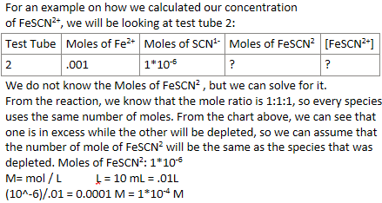

17. How would your team calculate the diluted molarity of Fe3+ in test tube #6? This question requires an answer in a sentence not a calculation. - We can get the calculated concentration and subtract from it the actual concentration we got from our absorbance concentration graph. Then we can use stoichiometry to calculate the remaining dilute concentration of the Fe3+.

or

We would compare the concentrated solution (Test tube 1) to our dilute solution (test tube 6), and use the formula M1V1=M2V2, where the 1’s are the concentrated solution, and the 2’s are the dilute solution.

18. For your team's test tube samples 6-10, show the calculations for determining the diluted molarities of Fe3+. (Hint: how many moles Fe3+ are in the total solution volume in each test tube?) - Since all of the tubes use the same volume of the same M solution, all the tubes would have a dilute molarity of what was calculated above.

19. For your team's test tube samples 6-10, show the calculations for determining the diluted molarities of SCN-. (Hint: how many moles SCN- are in the total solution volume in each test tube?) - 

20. When the Fe3+ and SCN1- solutions were mixed, a reaction began to occur and formed FeSCN2+. During the reaction did the concentrations of each of the reactants Fe3+ and SCN1- increase or decrease? What happened to the concentration of the product FeSCN2+? - The reaction will make the reactants (Fe3+ and SCN1-) decrease in concentration, while the product (FeSCN2+) will increase in concentration.

21. Considering that Fe3+ and SCN- react to in a 1:1 ratio to form the colored ion FeSCN2+, what is the theoretical maximum molar concentration of FeSCN2+ for the solution in test tube #6? - Because test tube 6 has 1ml of .002 M SCN-, and that this is the limiting reactant, the max molar concentration would be 2*10-6M.

22. How did the concentration of FeSCN2+ in test tube #6 recorded in Table 7 compare to the theoretical maximum concentration calculated in the question above? Give reasons why they were the same or different.- My recorded concentration was 0, so they were different. I either messed up in the lab by not adding the correct amount of the SCN-, or the colorimeter could not read the absorbance of the solution because the light was barely diffracted due to the low molarity of the solution.

23. What conclusion(s) can be drawn regarding the completeness of each of the test tube 6-10 reactions? - The tubes get more complete as the concentration of SCN- increases?

24. If the concentration of a reactant falls during the reaction, how can its final concentration be determined from its initial diluted concentration and the final concentration of the product? (Hint: use stoichiometry) - We can convert the Molarity of the product into mols (by multiplying it by the volume of the solution), use stoichiometry to convert the moles of product to moles of the initial reactant, then convert that to Molarity (by dividing it by the volume of the solution).

25. Did the calculated equilibrium constant vary from solution to solution? Should it have? - Yes, yes

26. What range of variation did your team's test tube values show from the average? (Express as average Kc ± max difference from average Kc). - 2.59226E8, yes I know more than half of this math is wrong

27. Based on the average value of the equilibrium constant, does your team think this reaction favors the product or the reactants? Why? - Products, bigger Kc

* Do not forget to attach the signed lab work-out

